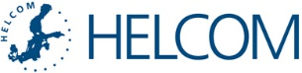

Mr President, Ministers, Your Excellences, Distinguished Guests,
I would like to congratulate the Baltic Sea Parliamentary Conference for the 25th anniversary and thank you for all the efforts and remarkable achievements during these last two and half decades in bringing all nations around the Baltic Sea together to promote sustainable development of our region.
The BSPC has been very supportive of the HELCOM work for the Baltic Sea marine environment, for which I am very grateful. Healthy marine ecosystems are needed to ensure a thriving maritime economy and the wellbeing of people. A healthy sea is very important for the future: so that people can eat fish from this region, such as cod and salmon, without concern about their health and can swim in the sea waters. We must also ensure that tourists keep coming back to the Baltic Sea shores, and that there is enough sea space for new activities that we might not even be able to imagine today.
The focus of our HELCOM work is to achieve this goal. The HELCOM Baltic Sea Action Plan from 2007 remains a major regional programme of actions for our Contracting Parties – governments of the nine coastal Baltic Sea states and the European Union, to implement. Our deadline for fulfilling the commitments is year 2021, and already I can report to you some concrete achievements, especially in reducing inputs of excessive nutrients – nitrogen and phosphorus - which are responsible for eutrophication and algal blooms.
This year the Baltic Sea coastal countries agreed and submitted a proposal to the International Maritime Organization, IMO, the global regulator of shipping, to designate the Baltic Sea as a NOx Emission Control Area (NECA). NECA means a special area where the emission of nitrogen oxides is controlled according to the IMO MARPOL Convention Annex VI. The proposal was made in parallel with the North Sea countries.
The initiative for a Baltic Sea NECA was agreed upon in 2007. Since then HELCOM has carried out the necessary environmental and economic studies and conducted intensive negotiations on the right timing for a final submission to IMO. With this measure there is potential to cost-efficiently reduce around 7000 Nitrogen input to the Baltic Sea per year. There will be a time lag for fleet renewal, as the regulation addresses only new ships. This reduction is significant: for several coastal countries it exceeds their entire national Nitrogen pollution reduction commitment according to the HELCOM requirements.

Another milestone in curbing nutrient inputs is the ban to discharge untreated sewage from passenger ships in the Baltic Sea. This year the Contracting Parties have finally fulfilled the formal conditions for the ban to be enforced, and the new regulations will take effect by 2021 at the latest for most of IMO registered passenger vessels. (For new ships built on or later than 2019, these requirements will apply earlier, and in certain cases of direct passages between St. Petersburg area and the North Sea there is a two-year extension to the deadline, until 2023).
We now have to make sure that all the necessary improvements to facilities in ports of the Baltic Sea to receive sewage are done.
HELCOM cooperation with IMO and industry stakeholders on the establishment of these special regimes for ships operating in the Baltic Sea is an example of successful regional cooperation across sectors to implement global regulations. These new regulations can also be expected to boost competitiveness, technological development and innovation.
Cooperation between sector ministries and industry has also been crucial in developing the new HELCOM Recommendation on sustainable aquaculture in the Baltic Sea. The Recommendation is soft law, meaning that the governments will translate it into national law or otherwise ensure its implementation. The Recommendation provides criteria for best practices for minimizing and preventing negative environmental impacts of aquaculture, including freshwater and marine fish farming.
Almost all possible traditional solutions and straight-forward measures to protect the marine environment have been taken into use in the Baltic Sea. Further measures are more complex and require holistic thinking and innovative approaches, as well as greater involvement from sectors. Cost-efficiency and economic benefits derived from the protection of the marine environment play an increasingly decisive role.
HELCOM has existed for over four decades. With our long history of cooperation, it is vital that we follow up on the implementation of our commitments. We must demonstrate progress and the added value of our work.
The Contracting Parties implement the Helsinki Convention, which is a legally binding regional treaty, as well as HELCOM Recommendations, which can been seen as our executive orders. The Contracting Parties also report on the progress made.
In addition, decisions made by the Ministerial Meetings are an important part of the “HELCOM acquis”. We have evaluated to what extent the most recent Ministerial commitments have been implemented. The evaluation covers the Baltic Sea Action Plan from 2007, adopted at the Krakow Ministerial Meeting, as well as two follow-up Ministerial meetings.
Does HELCOM as a whole stick to its decisions?
Here In figure you can see how many joint actions agreed by each of the Ministerial Meetings have been accomplished, partly accomplished, or not at all accomplished.
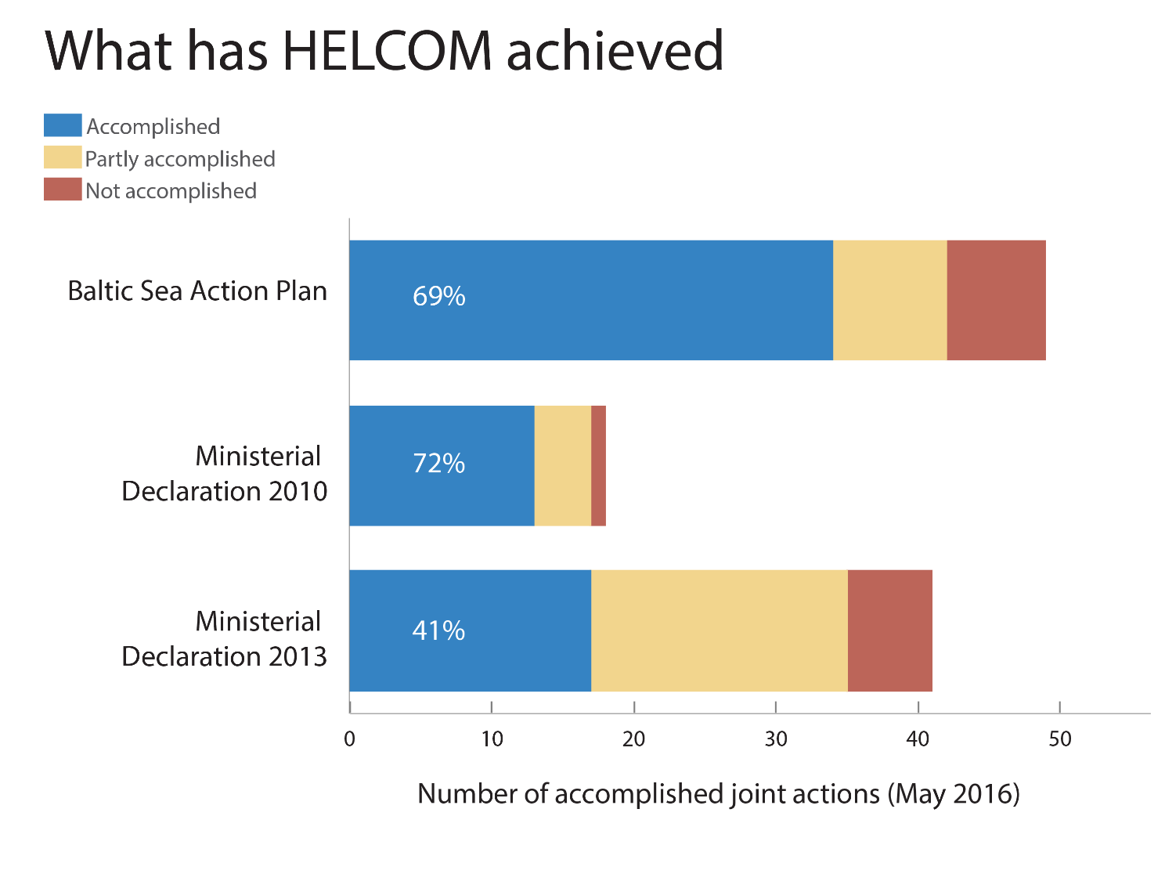
Overall, 60% of the agreed regional actions have been completed, but over 40% actions still remain only partially implemented.
It is evident that a lot of work has been done and significant progress is being made.
Based on what we know now, however, I must say that we are quite far from reaching good environmental status for the Baltic Sea. There are still many areas of concern and where further implementation is needed: for instance for the Regional Action Plan on Marine Litter, nutrient accounting on farm level and nutrient recycling, impacts of underwater noise on biodiversity, Marine Protected Areas, and sustainable fisheries. Further, countries need to carry out transboundary consultation of their national maritime spatial plans to ensure the coherence of these plans and overall suitable development. Guidelines on such consultations have just been adopted by HELCOM and our partner initiative VASAB.
Still, I would like to end on a positive note.
Let’s take a look at inputs of phosphorus coming from rivers flowing into the largest sub-basin of the Baltic Sea - the Baltic Proper, which also has a major influence on the status of eutrophication in some neighbouring sub-basins. The available data series cover a period of over a hundred years, which highlights how much patience and consistency is needed in successful marine environment policy-making.
Starting from 1950s there is a steep increase in inputs, peaking in the early 80s. But since then, there has been improvement and the inputs have decreased. The final step, of course, is to reach the target set for 2021. The target is ambitious and might be quite challenging to achieve. I hope HELCOM can rely on the support from the Baltic Sea Parliamentary Conference to make it possible.
Thank you!
Monika Stankiewicz
HELCOM Executive Secretary

