Version: 27.08.2019

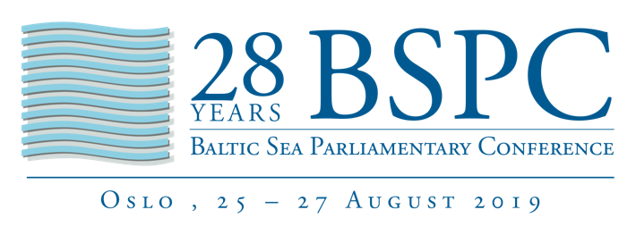

Speech by Mr Valerijus Simulik

Vice-President of the Baltic Sea Parliamentary Conference (BSPC)

28th BSPC

Transfer of the presidency

Oslo, Stortinget

27 August 2019

Check against delivery

Dear President, dear Jorodd,

On behalf of everyone present here, thank you and thanks to the Stortinget for having hosted the 28th Baltic Sea Parliamentary Conference in a genuine atmosphere with generous hospitality as well as inspiring discussions and debate. I believe I speak for all of us present when I say that this has been an excellent conference! It is always a pleasure to visit Norway and the impressive city of Oslo. This has been a perfect venue for the BSPC!
Both the parliament building as well as the city and the country are something extraordinary. This parliament, with its long tradition, has once again deeply internalised the fundamental importance of parliamentarism and parliaments. Oslo and Norway as a whole have allowed us to look beyond the Baltic Sea. We’ve become aware that our decisions on maintaining the health of the Baltic Sea contribute to the protection of the seas as a whole. The better we are in the Baltic region in this respect, the more we can influence developments in other seas as a best practice example.

This conference again underlined the vital importance of international parliamentary cooperation – especially in times of crisis.

The decisions we made include the expectation to move our macro-region another step closer to a better future. This conference gave us the possibility to get to know
new colleagues from other parliaments, ministers and experts. And it has been an opportunity to deepen long-standing friendships. I hopefully will meet most of you again.

Thank you, Jorodd, for the professional and open-minded way you’ve led the work within the BSPC since we met in Mariehamn a year ago.

Thanks to everyone involved in the programme. It was very inspiring, and I think we all have learned a lot.

I would especially like to thank the working people… and of course the interpreters! You have all done a great job!

Next year, I will invite you to Vilnius (August 22 until 25). After 15 years, the BSPC will come back to Lithuania. The landscape may be the same; many historical buildings are the same, although restored and attractive again. But society and life have fundamentally developed since 2005.

We are an open-minded society, we want to have peace and fruitful cooperation, stability and safety.

We will meet in our new parliament hall.

During our Presidency, we want to place a special emphasis on what is particularly close to our hearts: a boost to innovation through science and technology and their interaction to achieve better added value in economic development based on science.

We want to push innovation on our way to a better future.

We need innovative impulses not only to increase our prosperity but moreover - as was shown in the climate discussions but also concerning the health of the oceans during this conference -, we want to get control back over our environment and solve problems intelligently.

And of course, this is all only possible if we live in a stable environment with stable democracies, peaceful and close neighbourliness around us based on democratic values, the Rule of Law, human rights and equal opportunities for everyone.

It is worth all the effort to deepen cooperation and integration for a secure and prosperous Baltic Sea region.

Let’s work on safeguarding and strengthening our parliamentary cooperation, especially in the face of common challenges.
We want all you parliaments and parliamentary organisations but also the CBSS and all our governments and partners to support us with your ideas, your commitment, your collaboration and your friendship for the sake of further prosperous development of our unique Baltic Sea Region.

Let’s begin our Lithuanian BSPC journey.

