Baltic Sea Parliamentary Conference
Adopted by the 26th BSPC on 5 September 2017

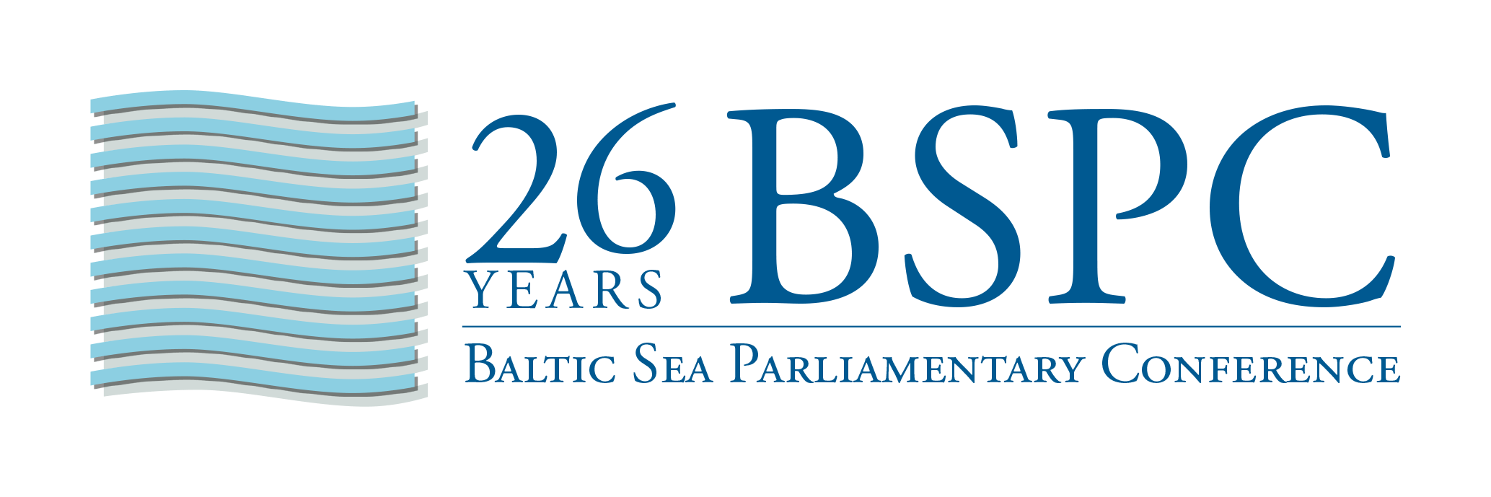

Baltic Sea Parliamentary Conference

Work Programme 2017 – 2018

1. BSPC Mission

The Baltic Sea Parliamentary Conference (BSPC) was established in 1991 as a forum for political dialogue between parliamentarians from all national parliaments, regional parliaments and parliamentary organizations in the Baltic Sea Region. BSPC also interacts with other parliamentary and governmental organizations in the Baltic Sea Region and the Northern Dimension area.

The mission of the BSPC is to raise awareness and opinion on issues of current political interest and relevance for the Baltic Sea Region. It promotes and drives various initiatives and efforts to support a sustainable environmental, social and economic development of the Baltic Sea Region. The BSPC strives at enhancing the visibility of the Baltic Sea Region and its issues in a wider European context.

BSPC shall initiate and guide political activities in the region; support and strengthen democratic institutions in the participating states; improve dialogue between governments, parliaments and civil society; strengthen the common identity of the Baltic Sea Region by means of close co-operation between national and regional parliaments on the basis of equality; and initiate and guide political activities in the Baltic Sea Region, endowing them with additional democratic legitimacy and parliamentary authority.

The BSPC Standing Committee may consider any matter of specific interest and relevance for the Baltic Sea Region, and may also give its opinion on such issues.

The political recommendations of the annual Parliamentary Conferences are expressed in a Conference Resolution adopted by consensus by the Conference. The adopted Resolution shall be submitted to the governments of the Baltic Sea region, the CBSS and the EU, and disseminated to other relevant national, regional and local stakeholders in the Baltic Sea region and its neighbourhood.

2. BSPC Priorities in 2017 - 2018

The priority issues for the BSPC Standing Committee in 2017 – 2018 are:

- Sustainable societies in the Baltic Sea region based on democratic values, human rights and equal chances for all

- Cooperation and integration for a secure and prosperous Baltic Sea area

- Migration and integration,
finding solutions based on mutual information and best practices

3. Objectives of the BSPC in 2017 - 2018

The objectives of the BSPC in 2017 – 2018 are:

- To disseminate the 26th BSPC Resolution to Parliaments and Governments in the Baltic Sea region, as well as to the CBSS and the EU, and to take initiatives and action – such as interpellations, parliamentary debate and questions to the governments - to follow-up the implementation of its political recommendations;

- to disseminate the results and recommendations of the BSPC Working Groups, Rapporteurs and Observers, for instance by advocating them in the home parliaments of the BSPC delegates and through interaction with external institutions and organizations;

- to support the policies of the CBSS and to further the co-operation between the CBSS and the BSPC, for instance by sustaining contacts and cooperation between secretariats, by synchronizing priorities as far as possible, and by maintaining an interaction between working bodies of the BSPC and the CBSS, such as the BSPC Working Groups and the CBSS Expert Groups and Task Forces;

- to promote the implementation of the HELCOM Baltic Sea Action Plan, including measures against Eutrophication, for instance by active participation in various HELCOM meeting formats;

- to promote the further development of the Northern Dimension, including its parliamentary dimension, and the European Neighbourhood Policy, for instance by actively taking part in relevant activities and by exchanging views and positions with relevant bodies of the European Parliament;

- to support the development of the EU Strategy for the Baltic Sea Region that is fully aligned with the Northern Dimension, including regular reporting from the European Commission;

- to further develop contacts and interaction with the Northern Dimension Partnerships;

- to actively participate in and contribute to the further progress of the Baltic Sea Labour Forum (BSLF).

4. Resources 2017 - 2018

The BSPC has several working bodies, which serve as resources for driving and implementing BSPC priorities and objectives.

The Baltic Sea Parliamentary Conference is the annual general assembly in the Baltic Sea region for broad political debate on Baltic Sea issues. The Conference resolutions are political tools which enables the BSPC to take and support political initiatives, and to approach the governments and regional organizations on issues ofacommon interest.

The host country of the 27th BSPC, Åland Islands, is responsible for the operational planning and execution of the 27th Conference in Mariehamn on 26 – 28 August 2018.

The BSPC Standing Committee (SC) is the highest decision-making body of the BSPC between the annual Conferences. The Standing Committee considers and decides on strategic issues concerning the mission, political priorities, working modes, finances and administration of the BSPC. The Standing Committee has the overall responsibility for preparing the annual Conference and for overseeing the structures and functions of the BSPC. The Standing Committee consists of parliamentarians from all national parliaments, regional parliaments and parliamentary organizations throughout the Baltic Sea Region. The Standing Committee convenes at least four times per year (beginning of the year, spring/summer, in connection with the Conference, and in fall). The first SC meeting of the year should include a report from the CBSS and could also include progress reports on EU Northern Dimension, EU Baltic Sea Strategy, and EU Integrated Maritime Policy. The SC also serves as Drafting Committee during the annual Conference.

The BSPC Secretary Level meeting consists of officials from the BSPC member parliaments. It supports the Secretary General in preparing the work of the Standing Committee, and oversees the preparations of the annual Conferences.

The BSPC Secretary General manages overall coordination of BSPC activities, prepares activities in the BSPC bodies, delivers administrative and organizational support, and provides investigative resources.

The BSPC Working Group on Migration and Integration will aim at elaborating political recommendations within this field. The Working Group will present its midway report at the 27th BSPC and its final report at the 28th BSPC.

The BSPC Observers in HELCOM, Sylvia Bretschneider (Mecklenburg-Vorpommern) and Saara-Sofia Sirén (Finland) follow the deliberations of relevant HELCOM bodies.

The BSPC Rapporteur on Cultural Affairs, Karin Gaardsted (Denmark), follows and reports on developments in this field.

The BSPC Rapporteur on Trafficking in Human Beings, Thomas Stritzl (Germany), follows and reports on developments in this field.

The BSPC Rapporteur on Eutrophication, Saara-Sofia Sirén (Finland), will follow and report on the development in these fields and the implementation of the recommendations of the BSPC Working Group on Eutrophication (2006-2007).

The BSPC Rapporteurs on Sustainable Tourism, Sylvia Bretschneider (Mecklenburg-Vorpommern) and Sara Kemetter (Åland Islands) are co-rapporteurs that will follow and report on the development in this field and the implementation of the recommendations of the BSPC Working Group on Sustainable Tourism (2015-2017).

The BSPC Rapporteurs on Integrated Maritime Policy, Jochen Schulte (Mecklenburg-Vorpommern) and Jörgen Pettersson (Åland Islands) are co-rapporteurs that will follow and report on the development in this field and the implementation of the recommendations of the BSPC Working Group on Integrated Maritime Policy (2009-2011).

The BSPC Rapporteur on Innovation in Social- and Healthcare, Olaug Bollestad (Norway), will follow and report on developments in this field and on the implementation of the recommendations of the BSPC Working Group on Innovation in Social- and Healthcare (2013-2015).

The BSPC Rapporteur on Labour Market and Social Welfare, Pyry Niemi (Sweden), will follow and report on the development in these fields and the implementation of the recommendations of the BSPC Working Group on Labour Market (2007-2009).

The BSPC Rapporteurs on Green Growth and Energy Efficiency, Cecilie Tenfjord-Toftby (Sweden) and Oleg Nilov (Russian Federation), will follow and report on the development in this field and the implementation of the recommendations of the BSPC Working Group on Green Growth and Energy Efficiency (2011-2013).

The BSPC Website (http://bspc.net) is a central conduit for disseminating news and information on BSPC’s organization, activities and results, as well as a dynamic archive to BSPC documents and opinions.

